Chapter 10, Problem 14.

Calculate the voltage at nodes 1 and 2 in the circuit of Fig. 10.63 using nodal analysis.

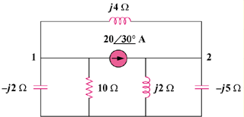

Figure 10.63
For Prob. 10.14.

